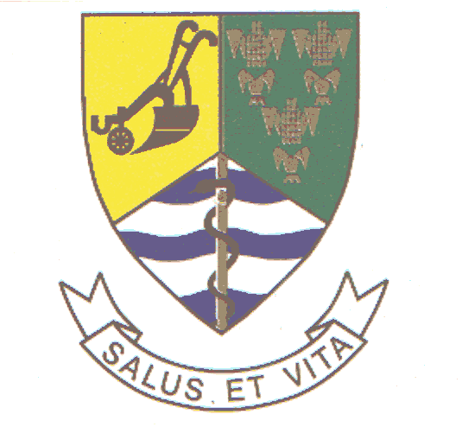

Welcome address by Clr Maloka (Speaker) on behalf of Mayor of Bela-Bela
SMME National Summit: 29 August 2007
Forever Resorts, Bela Bela

Programme Director
Minister Mandisa Mpahlwa
MEC for Economic Development and Tourism Collins Chabane
Other MEC presents from our provincial governments
Business leaders
Members of the academia
Delegates
Ladies and Gentlemen

A very good evening to all of you

Firstly, I must indicate that our Mayor would have like to be here with us this evening, however due to prior commitments, she has requested me to come and welcome you to our beautiful municipality.

She has also requested me to send her apologies.

Programme Director

It is indeed an honour for us, as the Bela-Bela Local Municipality, to have been chosen to host such an important summit.

For us, this summit, is but one of the many decisive steps, that our government is taking to ensure that at the local sphere, we are able to discuss and create platforms for both the private and public sector to exchange views on this very critical component of our economy – that is ensuring that Small businesses are supported, through legislation and other mechanisms, to be an integral part of the economic development.

To this end, we fully welcome and support such initiatives that would promote entrepreneurship particularly within our previously disadvantaged communities, in the townships, villages and cities of our country.

Programme Director

This particular summit will also help to remind us, as the municipality and participants, of our responsibility and obligation to create a better environment for small businesses and enterprises to thrive both in domestic and international markets.

But importantly to ensure that municipalities like ourselves, who thrive on tourism, are able to support local small businesses, who are willing to become active role players in our country’s economy.

Programme Director

The Bela-Bela Local Municipality is the tourism hub of the Limpopo Province. Not only do we have the famous Big Five’s and other goodies in our municipality.

We have between 90 to 100 tourism facilities in the form of game lodges, resorts, conference facilities, impressive golf courses, health and Spa institutions and other established tourism attractions.

We are able to attract tourists from as far as the US, Germany, France, India and Brazil.

However there are a number of challenges, that as the local municipality, we still facing.

For instance, Programme Director, there is resistance in some quarters locally, to open up the tourism market for our people to participate and benefit from this thriving market and important industry.

Our people are just merely spectators to these positive tourism developments we all talking about. It is so primarily because the local tourism industry, which is the local economic driver, is been projected as exclusive terrain only for a certain section of our local population.

There are no direct linkages between small and big businesses, no support from the established role players locally, private sector and even within certain public agencies.

However we hope that through a summit of this nature, we will be able to compare notes, get expert advice and guidance from the business gurus, academics and our political leaders present here tonight.

Programme Director

Let me however take this opportunity, on behalf of the Bela-Bela residents, ratepayers, community and our council, to extend a warm hand of welcome to all the delegates and our visitors, and say as the municipality, we wish this critical summit success.

We also want to urge you to come back here later this year, with your families to spend you holidays in this beautiful municipality – the tourism hub of the Limpopo Province.

It is our believe here that there is no South African who can claim to be a traveler or tourist of note if he/she has never been to Bela-Bela and explore the beauty of our municipality .

I thank you

